Pricing Report
January 2024

Energy bills are driven by both the price of energy on the wholesale market and Third-Party Costs (TPCs). TPCs include non-energy costs set by the government, network (the National Grid), policy and system costs and electricity transmission/distribution costs.

The biggest single cost on a bill is the price of the wholesale energy (Commodity). Before the energy crisis the wholesale cost of energy made up approximately 40% of an electricity bill and 70% of a gas bill, with the remainder being third party charges (non-commodity). Commodity costs have been continuously rising in recent years and can be extremely volatile. Currently, with the latest rise in wholesale costs mean that they now make up around 78% of a gas bill and 72% of an electricity bill.

This pricing report will focus on the wholesale element of an energy price to help you keep track and understand the wholesale energy market and the factors affecting the price of your contracts.

Overview:
Temperatures have dropped across Europe to below seasonal norms which has led to a surge in both power and gas prices as markets brace for an increase in demand. Wind speeds have also dropped below their typical levels and are expected to remain low.

Despite the expectation of higher withdrawals, reserves stand at a healthy 86.07%, indicating a stable supply. Moreover, the arrival of 14 LNG cargoes by the 20th of January is poised to contribute further stability to prices, countering the impact of lower temperatures and increased heating demand.

It's important to acknowledge the inherent volatility of the energy market and prices which are very susceptible to influences such as weather conditions, currency fluctuations, and shifts in supply and demand. With current upward trends in prices, considering evaluating rates sooner rather than later is advisable.

Bullish Factors (upward pressure on markets):
- Temperatures below seasonal norms
- Higher storage withdrawals
- Drop in wind speed

Bearish Factors (downward pressure on markets):
- Ample supplies of LNG to the UK this month
- Storage volumes just under 90%

Gas and Power
MARKET REPORT
Despite the anticipated colder temperatures for the remainder of the month, gas storage levels in both the UK and Europe have stayed robust.

Healthy supplies and imports have contributed to price stability, even with a forecasted 20% lower demand for heating and wind generation compared to seasonal norms.

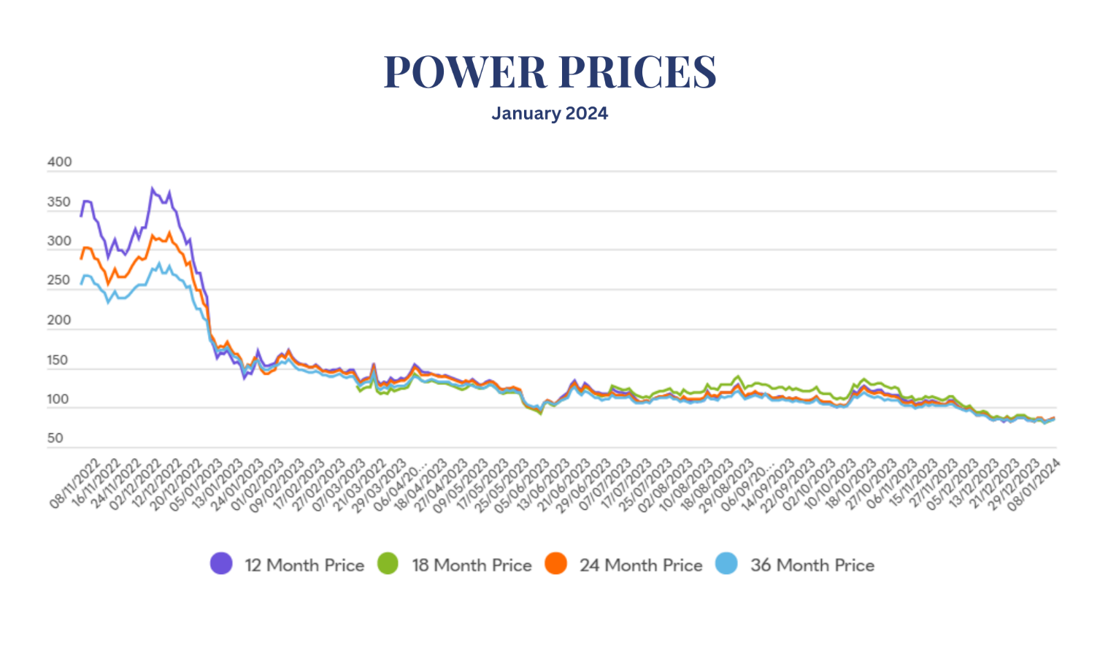
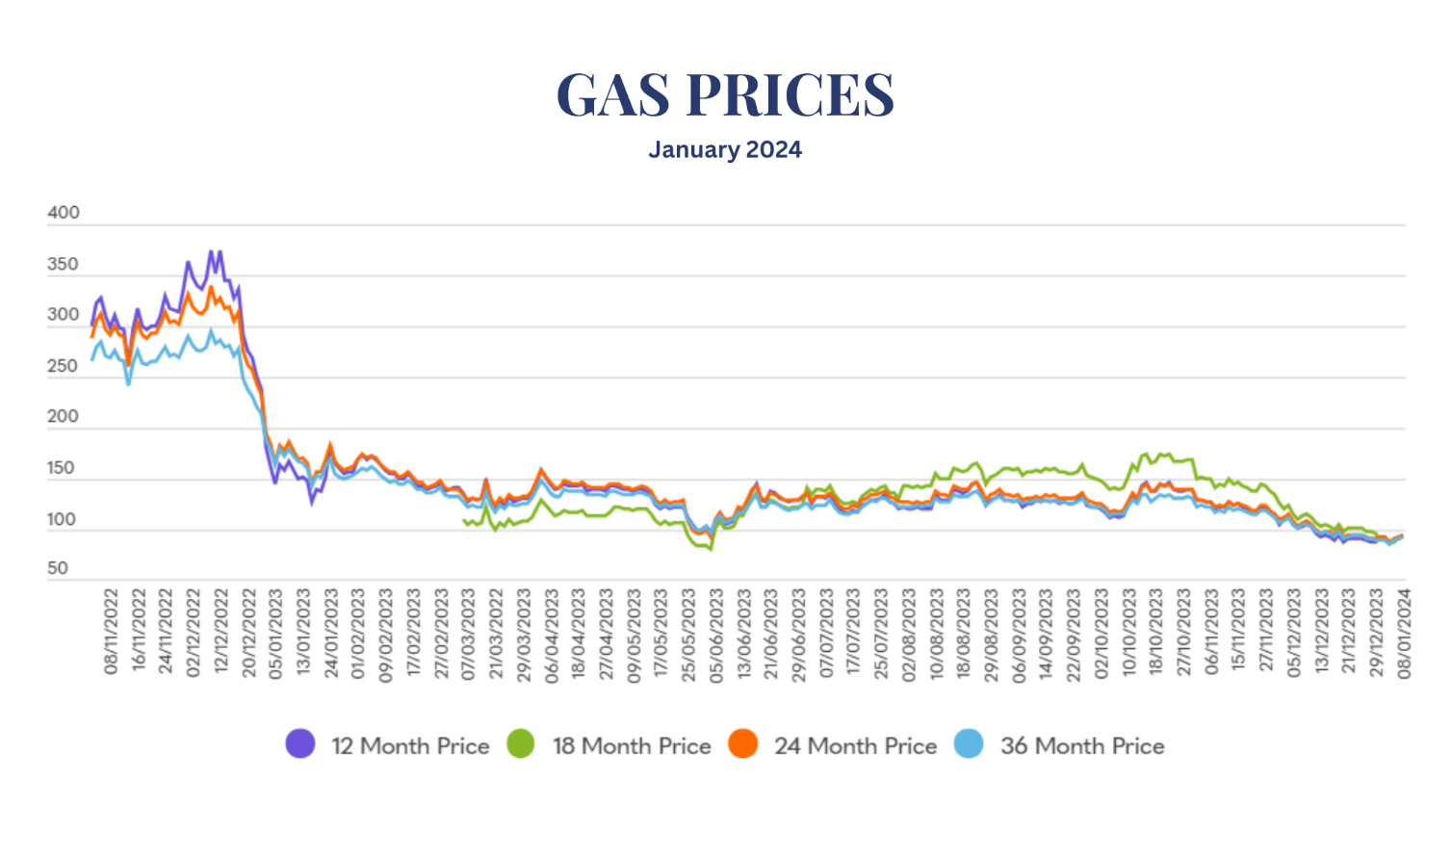
Graphs below display gas and electric prices over the last 12 months.

Ukraine's Crucial Role in European Natural Gas Stability
ENERGY NEWS
Natural gas prices spiked by 5% on the 3rd of January below-average freezing temperatures until mid-January. The impending cold snap is set to boost gas demand for heating and electricity.

Despite this spike, European gas prices have been declining over the last few months due to an ample supply of inventory levels across the continent. European companies strategically rely on Ukraine for gas storage, enhancing energy security and stabilising the market. Companies are accelerating withdrawals from Ukraine's gas storage alongside small drawdowns from repositories of European storage.

“Ukraine is playing a key role for central and eastern Europe’s security of gas supply this winter,” said Natasha Fielding, head of European gas pricing at Argus Media, a price reporting agency.

Calling on gas stored in Ukraine “helps Europe to keep its domestic stockpiles high, reducing the risk of sites nearly emptying over any sustained cold in late winter”, she said.

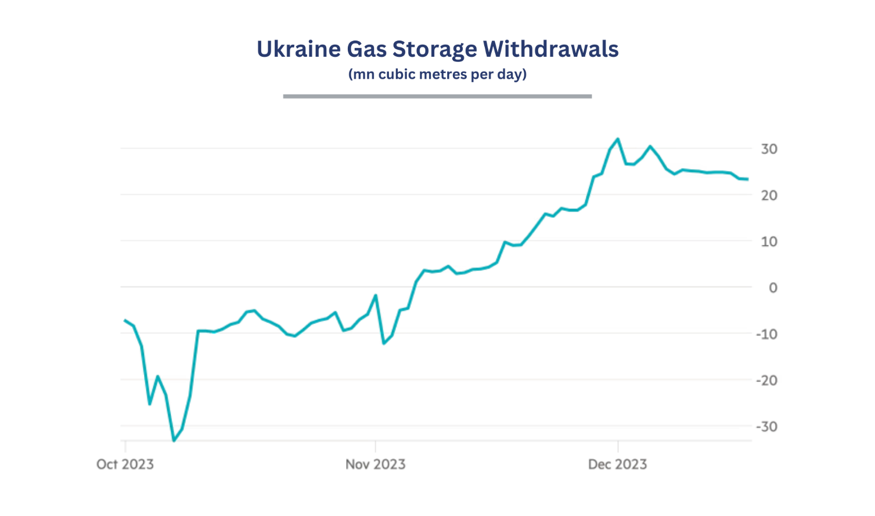
This strategy ensures there are high storage levels throughout winter, easing the challenges of refilling during the summer for the subsequent winter, thereby mitigating the risk of an energy crisis.

