Pricing Report
5th July 2021

Energy bills are driven by both the price of energy on the wholesale market and Third-Party Costs (TPCs). TPCs include non-energy costs set by the government, network (the National Grid), policy and system costs and electricity transmission/distribution costs.
The biggest single cost on a bill is the price of the energy. The wholesale cost of the energy makes up approximately 40% of an electricity bill and 70% of a gas bill, with the remaining being TPCs, which have been continuously rising in recent years and can be volatile.
This pricing report will focus on the energy element of a bill to help you keep track and understand the wholesale energy market and the factors affecting the price of your contracts.

Overview:
UK gas prices closed at some of their highest levels since 2008 last week, with prices 131% higher than this time last year. We usually see a period of storage injections, but with the colder temperatures this year increasing the demand for gas there is little left in reserve and adding risk.

Prices have been pushed higher further by the unplanned outages and continued concerns over the UK storage levels. Fewer supplies are expected into Europe, with LNG (Liquified Natural Gas) heading out east where they are willing to pay more. Low renewable output has also helped support the 1% gains of crude prices, all contributing to the increase in contract prices.

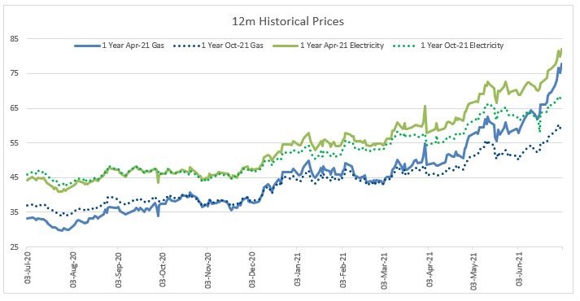
Crude oil prices dropped slightly at the start of last week ahead of the OPEC+ meeting and the risk of the Delta COVID variant threatening to impact world economies. They have since reversed due to the supply concerns and extremely high temperatures in the US and Canada and WTI crude is now currently trading at 2.9% higher than the start of the week.

To avoid these prices, you can look at securing a rate today for your future contracts. We have already seen 12 and 24 month contract prices shoot up and with the supply outlook looking more concerning and the UK expected to be "back to normal" by the 19th of July, the demand surge will outweigh the supply and push contract prices even higher.

Bullish Factors (upward pressure on markets):
- Expectations of extremely tight gas and electricity supplies across Europe - planned maintenance, unplanned outages and no LNG (Liquified Natural Gas) coming into Europe.
- Continued concerns around UK storage levels.
- Global energy demand is expected to increase.
- Low renewable generation, putting more demand on energy produced from fossil fuels.

Bearish Factors (downward pressure on markets):
- Investors eyed a potential increase in production quotas as OPEC members decide on a proposal.
- A reported increase of the new Delta variant of coronavirus which has sparked fears of a global slowdown of lockdown measures.

MARKET REPORT
Gas and Electricity
Both gas and electricity contract prices have increased even further, following the expectations of low supplies across Europe, as planned maintenance and unplanned outages reduce supplies, with further upside dealt from the strengthening coal and carbon markets.

Gas contracts have gained further value as the Asian premium continues to attract LNG shipments away from Europe and the UK.

The UK electric price monthly average is also the highest it has been in the last 5 years, as shown in the graph below, with wholesale oil prices still trading high and the expectations of a demand recovery remaining positive.

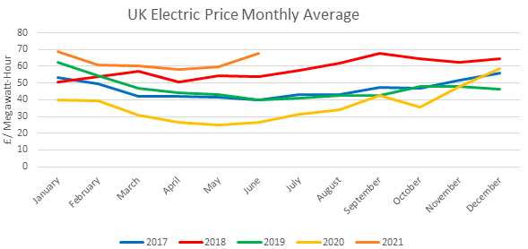
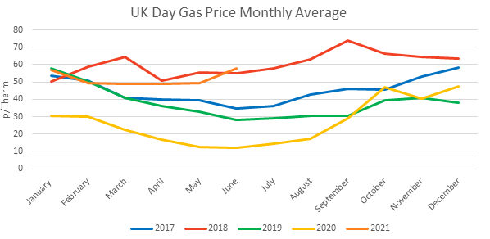

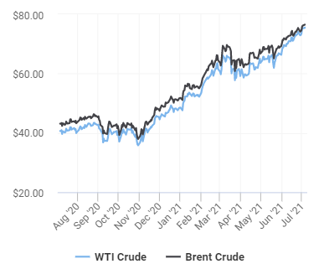
Crude
Brent crude initially lost value at the start of last week as investors paused ahead of the upcoming OPEC meeting with market participants expecting an increase in oil production quotas.

Brent and WTI have firmed throughout the week with confidence that global demand is expected to increase despite the new variant triggering new/extended restrictions.

Brent is currently trading 76% higher than this time last year and WTI has also increased by 84.9%.

Current price standings:
Brent Crude = $76.06/bbl
WTI Crude = $75.17/bbl

ENERGY NEWS
Spike in New Cases Delay Lockdown Lift
12 and 24 month term contracts have opened increasingly high since last week, especially for gas contracts.

As mentioned before, there has been a lot of concern around the UK supply levels and issues in building the inventory, especially for use in the winter months.

The temperatures this year were below seasonal norms, meaning more gas supplies were withdrawn from storage to keep up with the increased demand. Planned maintenance at the Nord Stream 1 and Yamal pipeline and unplanned Norwegian outages have resulted in low gas supplies. No Liquified Natural Gas (LNG) is coming into Europe either, as premiums have increased and the East are willing to pay more for the gas.

Currently. UK gas storage is at 15% capacity, providing a lot of risk for this winter. With pipelines being offline for longer than expected, in the last 2 weeks, we have also taken 15% of gas out of the already low storage levels.

Why have gas prices increased even further this week?

- Carbon prices have recently broken the 10th "new record high" in 2021 alone. This puts pressure on gas prices as gas is less expensive and "cleaner" than coal and because of the extremely high prices, gas demand is greater than other fuels to generate power due to fuel switching.
- There is an auction on the Sudzha terminal on the Ukraine/Russian border. No additional capacity was booked which means there will not be any increase in Russian flows through Ukraine into Europe during July.
- The Yamal and Nord Stream pipelines will be offline 6th-10th July and 13th-24th July respectively due to maintenance. This will significantly reduce Russian flows into Europe. Storage is therefore unlikely to be balanced with the reality that no extra volume will arrive in Europe due to the Sudzha auction. Gas is currently flowing at 320mcm a day to Europe (twice the amount for total UK demand). When the Yamal pipeline goes offline, this volume will fall to 264mcm and to 160mcm when Nord Stream is offline.

In conclusion, with already low supplies and more outages, the gas market is likely to be short for the winter months. Contract prices are high now as suppliers plan how much energy they will need and forward buy. If you are looking at renewing your contract later this year, we would advise comparing prices now to see your options and secure today's rates before they increase even further.

