Pricing Report
4th September 2020
Energy bills are driven by both the price of energy on the wholesale market and Third-Party Costs (TPCs). TPCs include non-energy costs set by the government, network (the National Grid), policy and system costs and electricity transmission/distribution costs.
The biggest single cost on a bill is the price of the energy. The wholesale cost of the energy makes up approximately 40% of an electricity bill and 70% of a gas bill, with the remaining being TPCs, which have been continuously rising in recent years and can be volatile.
This pricing report focusses on the energy element of a bill to help you keep track and understand the wholesale energy market and the factors affecting the price of your contracts.

Overview:
Coronavirus continues to be a large market driver, with easing measures balanced by new cases and enforced localised lockdowns.

At the beginning of the year, the wholesale price of oil was almost 40% higher than it currently is now, above $60/bbl. In March, as the virus spread and more countries reported cases of infections, the energy market dropped, with Brent dipping below $50/bbl. Come April, as countries went into lockdown with businesses closing and travel restrictions in place, wholesale prices plunged below $20/bbl, hitting an 18-year low.

Now, contract prices are on the rise and are almost back to pre-pandemic levels, as countries continue to handle localised outbreaks along with the introduction of Third-Party charges to balance the costs for suppliers.

Understanding your energy bills and searching the market for the best tariff when it comes to business energy can be complex and confusing, especially compared to searching for a domestic deal. We can help to remove this arduous task to save you time, stress and possibly money on your energy bills. All we need to run a free, no-obligation review of your energy is a copy of your latest bills. on your business. All we need to run a free, no-obligation review of your energy is a copy of a latest bill.

Bullish Factors (upward pressure):
- Positive Chinese manufacturing data, supporting indications of a recovery.
- Increasing demand and further planned Norwegian production outages.
- Unplanned maintenance at a Shell gas terminal.
- Pound sterling hitting a 3-month high, up a quarter of a per cent against the Euro and Dollar.

Bearish Factors (downwards pressure):
OPEC member countries increasing production levels.
Surges of new coronavirus cases, resulting in countries being removed from the travel corridor list.
Increase in wind generation meeting more of the UK's energy demand.
Gas and Electricity
MARKET REPORT
There was unplanned maintenance over the weekend at one of the Shell terminals which flows gas into the UK via the St Fergus terminal, which attributed to the increase in gas prices on Tuesday morning. This was short-lived though, with the work being completed on Wednesday.

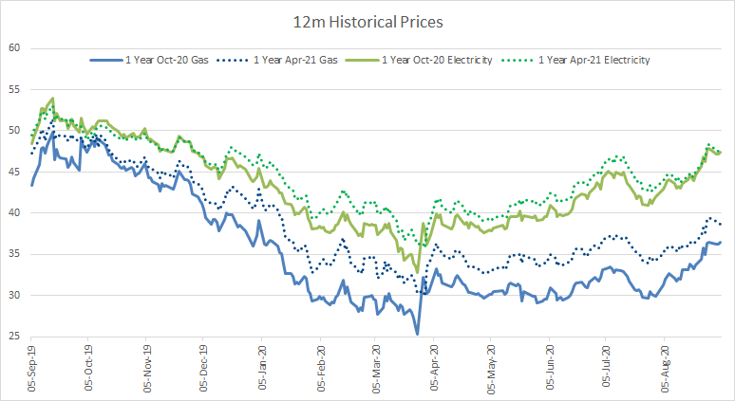
Both electricity and gas prices have decreased slightly in the week, as wind generation increased and met more of the UK's energy demand, requiring less reliance on burning oil for energy. However, stronger trading within the wider commodities has pushed contract prices higher today.

Crude
Oil prices have been steadily increasing over the last month, with Brent Crude increasing by 4.7% when compared to the beginning of August and WTI increasing by 6.2%.

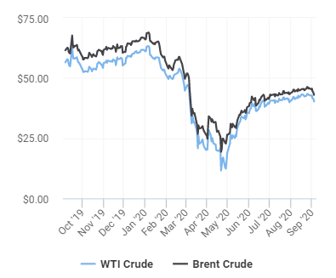
This has been supported by the increase in demand following positive Chinese manufacturing data and a report indicating US oil inventories has declined, which further support the hopes of a global recovery.

Prices have dropped slightly today, as data showed OPEC member countries had increased production during last month.

Current price standings:
Brent Crude = $43.01/bbl
WTI Crude = $40.27/bbl

ENERGY NEWS
Coronavirus Spikes
There have been several spikes in cases across popular tourist destinations, resulting in more countries being added to the "Red List". The most recent additions were the Czech Republic, Jamaica, and Switzerland on the 29th of August.

Cases are looked at per 100,000 people and any countries that are above 20 are likely to be added to the list of countries where tourists will need to quarantine for 14 days on arrival into the UK.

Portugal was added back to the exemption list less than 2 weeks ago but has since seen the number of cases rise. Many tourists looked to book early flights home, to avoid the possibility of having to quarantine, which saw flights from Portugal soar in price.

Ministers in England are also facing pressure on whether to remove Greece from the exemption list after Scotland and Wales introduced their own measures. Six clusters of cases have been linked to flights from the island Zakynthos - also known as Zante. After a flight back to Cardiff, nearly 200 people faced self-isolation after at least 16 passengers on a Tui flight tested positive for the virus.

If more countries are removed from the "safe countries" list and restrictions tightened, demand for oil will drop significantly as holidaymakers change plans and flights are cancelled, which will help to bring the wholesale price of oil down.

Signs of a Recovering Economy
UK economic activity improved over the summer months as coronavirus restrictions eased and government support measures underpinned consumer spending. However, big cities have not seen the same increase in spending activity that the smaller UK towns and cities have. This is likely to be a result of most office workers and commuters, who typically make up a large portion of high street footfall in metropolitan areas, still working from home or on holiday in mid to late August.

House prices in the UK also continued their post-lockdown recovery in August, recording their highest monthly rise in 16 years. Prices rose by 2% which has been the result of a range of factors, including demand carried over from lockdown or brought forward, owing to the temporary suspension of stamp duty for some homes. However, the number of sales is still comparatively low, making prices more volatile.

Oil prices were boosted further this week as manufacturing data from both the US and China looked positive and luxury car sales have improved, further supporting hopes of a global recovery.

Hurricane Laura
Hurricane Laura was a Category 4 Atlantic hurricane that tied the 1856 Last Island hurricane as the strongest hurricane on record to make landfall in the U.S. state of Louisiana, as measured by maximum sustained winds. Laura originated from a large tropical wave that moved off the West African coast on the 16th of August and became a tropical depression on the 20th.

The storm struck Louisiana, damaging buildings and cutting power, but sparing oil refineries from heavy flooding. US producers had shut 1.56 million barrels per day (bpd) of crude output, or 83% of the Gulf of Mexico's production, while nine refineries had shut about 2.9 million bpd of capacity, or 15% of US processing capacity, ahead of the storm.

Many refineries that were hit are now in the process of reopening and crude prices rebounded this week, as the decline in production levels due to the storm was not as bad as predicted.

partners@fidelity-energy.co.uk
08000 48 48 00

