Pricing Report
22nd October 2020
Energy bills are driven by both the price of energy on the wholesale market and Third-Party Costs (TPCs). TPCs include non-energy costs set by the government, network (the National Grid), policy and system costs and electricity transmission/distribution costs.
The biggest single cost on a bill is the price of the energy. The wholesale cost of the energy makes up approximately 40% of an electricity bill and 70% of a gas bill, with the remaining being TPCs, which have been continuously rising in recent years and can be volatile.
This pricing report focusses on the energy element of a bill to help you keep track and understand the wholesale energy market and the factors affecting the price of your contracts.

Overview:
As coronavirus spreads across countries, new restrictions and lockdown measures are being implemented which will have a knock-on effect on the demand for energy. How this will impact contract prices now is unknow, as Third-Party Charges have been added to help balance the markets and costs for suppliers.

Electricity prices have increased by over 40% since they fell in March and are now back to pre-pandemic prices. Gas prices are still over 10% lower when compared to this time last year, but are expected to continue to rise as the temperatures drop and the need to heat homes and offices increases, so there is still time to secure a lower rate for your next contract.

Oil production in Libya has restarted and increased the supply levels even further, putting oil prices under pressure from the threat to demand as the global resurgence in coronavirus cases continues. The Joint Ministerial Monitoring Committee (JMMC), for OPEC and non-OPEC members, took place on Monday, to discuss the latest market developments and whether or not to continue with their plans to ease cuts from January 2021, though we will likely have to wait for the full group meetings on the 30 November and 1 December for a concrete decision.

The International Monetary Fund (IMF) has forecast that oil prices will remain in the $40 to $50 range in 2021, which means that contract prices are unlikely to drop back to where they were in March, so speak to a member of the team to see if you can secure a saving on your next energy contract, today.

Bullish Factors (upward pressure):
- Drops in forecasted temperatures resulting in surges for gas demand.
- OPEC+ members meeting to discuss further potential production cuts to help balance out the supply levels.

Bearish Factors (downwards pressure):
- Warmer than average temperatures reducing the demand for gas.
- The rising number of new cases and new restriction measures in some European countries, weakening the price of Crude oil.
- Libya planning to increase output levels of oil production, despite the supply already being higher than the demand.

Gas and Electricity
MARKET REPORT
Gas and electricity contract prices are continuing to rise as we head further into autumn. Electricity prices are back to what they were this time last year and gas is looking likely to follow that trend as we head into the colder months and see the demand increase further, regardless of lockdowns or restrictions.

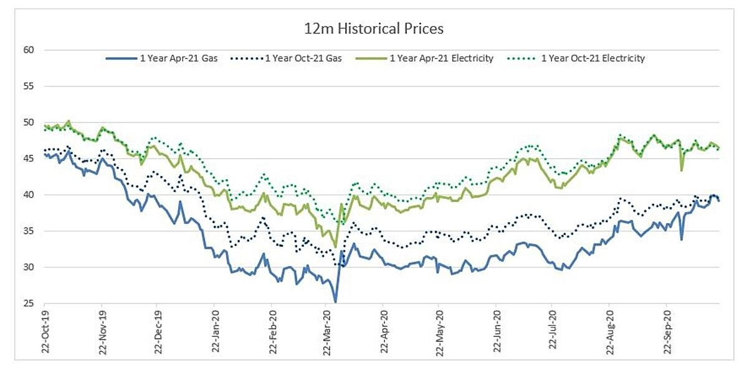
This time of year, as the temperatures and wind generation reduce the demand (especially for gas) rises to heat homes and businesses. The reliance on burning fossil fuels for power therefore also increases, which pushes an increase in contract prices.

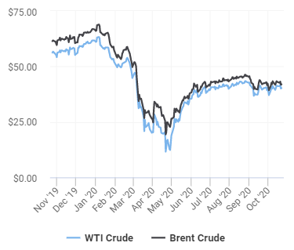
Crude
Oil has traded slightly lower this week, following new restriction measures in some European countries to help stem the rising numbers of new coronavirus cases.

This morning, Brent crude continued to trade lower as Libyan oil productions increases, despite speculation that OPEC member countries may extend their current production cuts to help balance a weakening demand outlook.

Current price standings:
Brent Crude = $41.99/bbl
WTI Crude = $40.28/bbl

Oil Supply and Demand
ENERGY NEWS
Libya’s daily oil production has risen to around 500,000 barrels, as the war-battered nation restarts its energy industry after a truce. Brent crude fell and the international benchmark was 0.6% lower last week following the news but has since recovered. The halt in Libya’s civil war led to many fields and ports in the east reopening last month, after an almost total shutdown of energy facilities since January. Before then, Libya was producing 1.2 million barrels a day.

Libya is home to Africa’s largest crude reserves and the return of its barrels is weighing on oil prices just as tighter virus restrictions in many countries sap demand for energy. The North African nation is an OPEC+ member, though it’s exempt from supply curbs initiated in May to boost oil prices, which are still down around 35% this year.

Currently, OPEC+ has agreed to keep to their reduced their levels of oil production until January, when they are due to start easing these cuts. However, considering that the second COVID-19 wave seems to be sweeping through Europe and threatening to derail economic and oil demand recovery, members are OPEC+ put together a panel to meet virtually this to discuss the latest supply and demand developments. A final decision is not likely to be made until their full group meetings at the end of November and comments during and after the meeting could swing oil prices in either direction.

Rise in COVID-19 Cases
As new cases of the coronavirus rise around the world and countries implement new restrictions, energy supply and demand will continue to be disrupted.

Localised and country-wide lockdowns will slow down the demand and the impact this is having on the energy markets evolves each day.

Power demand across Europe has slowly recovered since June with lockdown restrictions easing, the end of the holiday period as well as businesses and schools reopening. In September, demand across the 13 European countries analysed by the ICIS (the global source of Independent Commodity Intelligence Services) stood only 2% below the five-year average, up almost 5 percentage points compared with June.

However, with more lockdowns and restrictions coming into place as cases in the UK and across the world rise which would decrease the demand again, the pressure on an already oversupplied system remains high and weighs on oil markets.
partners@fidelity-energy.co.uk
08000 48 48 00

