Pricing Report
19th May 2022

Energy bills are driven by both the price of energy on the wholesale market and Third-Party Costs (TPCs). TPCs include non-energy costs set by the government, network (the National Grid), policy and system costs and electricity transmission/distribution costs.
The biggest single cost on a bill is the price of the energy. The wholesale cost of the energy makes up approximately 40% of an electricity bill and 70% of a gas bill, with the remaining being TPCs, which have been continuously rising in recent years and can be volatile.
This pricing report will focus on the energy element of a bill to help you keep track and understand the wholesale energy market and the factors affecting the price of your contracts.

Overview:
Energy demand in the UK has been above seasonal norms, despite the warmer weather, due to the increased demand for gas in Europe as Russian gas supplies to Europe have been decreasing.

The UK gas system has opened balanced this morning despite maximum exports to the continent via the IUK and BBL interconnectors. There are currently 4 LNG vessels confirmed as heading to UK terminals between 20th-23rd May, with 3 more possibly berthing at UK shores towards the end of the month, helping to keep steady prices slightly.

Oil prices remain volatile as the EU look to push for an oil and gas embargo on Russia. Prices edged higher following reports that Hungary is still looking to veto the embargo as they are almost completely dependent on Russia for oil.

Prices will continue to remain volatile and be impacted by any outcomes decided by or against Russia, such as an oil embargo increasing the demand for non-Russian sources of gas or if Russia continues to decrease or completely stop supplies to European countries who are largely dependent on them. We still recommend longer-term energy contracts, which can fix a price to avoid any further increases as well as provide budget certainty over the next few years.

Bullish Factors (upward pressure on markets):
- EU pushing for an oil and gas embargo
- Unplanned Norwegian outages
- Decrease in Russian gas supplies to Europe
- Reduction in wind generation
- China easing lockdown restrictions

Bearish Factors (downward pressure on markets):
- Weakening Chinese economy
- Demand for oil reducing

Gas and Power
MARKET REPORT
Contract prices increased this week following a reduction in wind generation as well as unplanned Norwegian outages which tightened UK gas supplies. Russian gas supplies to Europe have also decreased, pushing the Spot contract prices up.

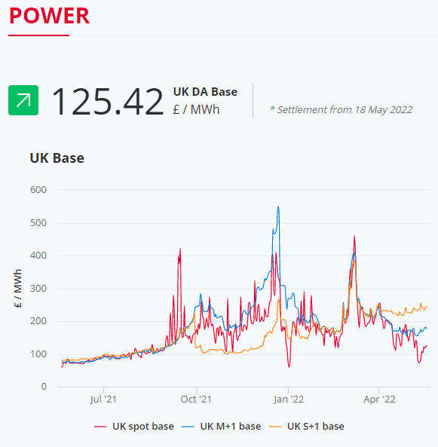
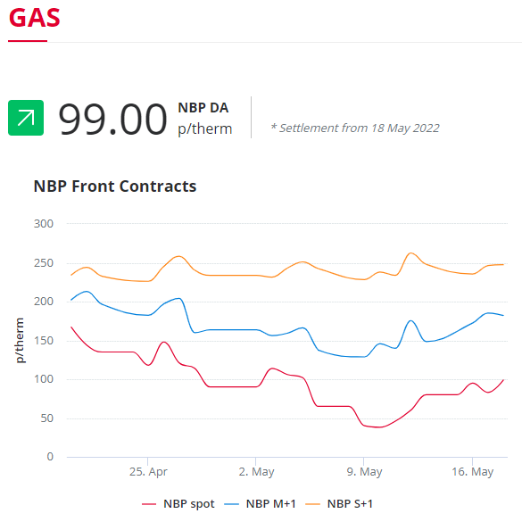
Due to a strong LNG supply outlook and healthy UK storage levels, prices for contracts starting for the next season (S+1) have decreased slightly.
In the graphs, you can see that gas contracts starting now (Spot) and those within the month ahead (M+1) are trading lower than those purchased now for the next season (S+1). Currently, this is due to the market volatility and uncertainty if Russia continues to decrease gas supplies to Europe.

A season in the business energy market is a 6-month spread and these are from April to September for "Summer" and October to March for "Winter".

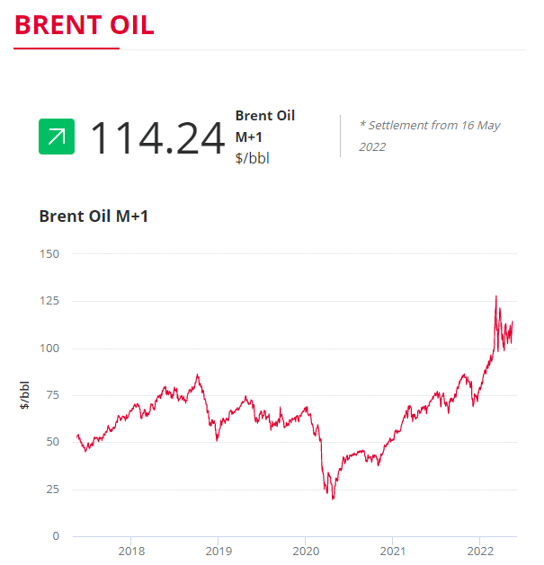
Crude Oil
Brent crude has remained volatile this week, as the EU pushed for a consensus on an oil and gas embargo and continuing concerns over a weakening Chinese economy reducing demand for oil. It has increased slightly, as China began easing some lockdown restrictions with no further new cases reported outside the quarantine zone in Shanghai.
Oil prices are 229% higher than this time in 2020 when demand was low and 47% higher than at the start of 2022.

Current price standings:
Brent Crude = $114.24/bbl

ENERGY NEWS
EU Oil and Gas Embargo on Russia
The EU is unable to agree on the sixth package of sanctions against Russia, as Hungary continues to block the proposed oil embargo. The latest sanctions are aimed at eroding the Kremlin’s ability to wage war. The EU has been unable to agree to its sixth package of sanctions against Russia – which includes asset freezes and travel bans on prominent Vladimir Putin supporters. However, Hungary, which is almost completely dependent on Russian imports for oil, is holding up an EU-wide embargo as it requires unanimity from all 27 member states.

Lithuania’s foreign minister, Gabrielius Landsbergis, said: “Unfortunately the whole union is being held hostage by one member state.” He was referring to Hungary, which continues to block the oil embargo, despite being offered an extension on phasing out Russian crude until the end of 2024. “Everybody expected this will be enough,” Landsbergis told reporters, reflecting the widespread view that Budapest would fall into line if it got more time to convert its energy system to accommodate non-Russian oil.

Hungary’s prime minister, Viktor Orbán, said on Monday that his country would not block EU sanctions against Russia as long as they posed no risk to Hungary’s energy security and blamed EU sanctions as partly responsible for high energy prices. “Every day Brussels abuses its power and tries to impose things on us that we do not want,” he said.

Other EU member states have voiced their impatience with the hold up. “We need to get on and do this,” Ireland’s foreign minister, Simon Coveney, said. “This is about a deterrent to the continuation of war. The sooner the EU can finalise that sixth sanctions package the better.”

Since the proposals, EU officials have made a series of concessions. A plan to ban EU ships from transporting Russian oil was dropped, after opposition from Greece and Cyprus, which worried their industries would lose out to competitors. Meanwhile, landlocked countries that are heavily dependent on Russian oil were offered a delay in joining the EU embargo. Hungary and Slovakia were given until the end of 2024, while the Czech Republic has been offered a June 2024 deadline. While Slovakia and the Czech Republic appear ready to sign off the sanctions, Budapest continues to hold out on the oil embargo, which the Hungarian prime minister, Viktor Orbán, has likened to an atomic bomb hitting his country’s economy.

